Changes 2016/07/31

1. Mixing slider - please add a value field which show changes while moving slider
Done
2. There should ba time left field shown of entire process remaining to finish (or at least % of processing advancement). It's very important as I am processing 500 files at once and it would be long process.
This feature required a bit of work because I had to rewrite the original encoding code to also output the status of each step and each pass. The program will display a message for each process step and display which file number of how many files it is busy doing.
Please remember that any speed issues is as a result of sox and lame as my program simply calls these external libraries for processing.
Done
3. I run it with 27 files I sent you for testing. It processed all 27 files in each directory but it processed only 12 files in the demo folder:
What is strange it display "status: creating watermarked files" and doens't make any progress it just processed all directories and stopped on 12th file in demo folder. It stays like that during last 20 minutes:
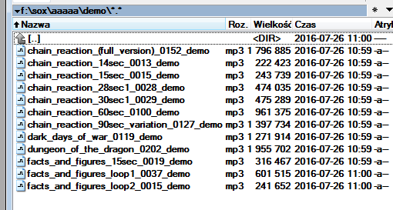
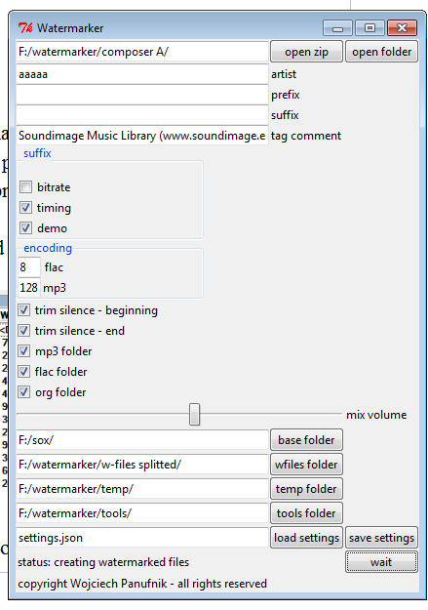

I also noticed that command line shows a lot of errors during processing:
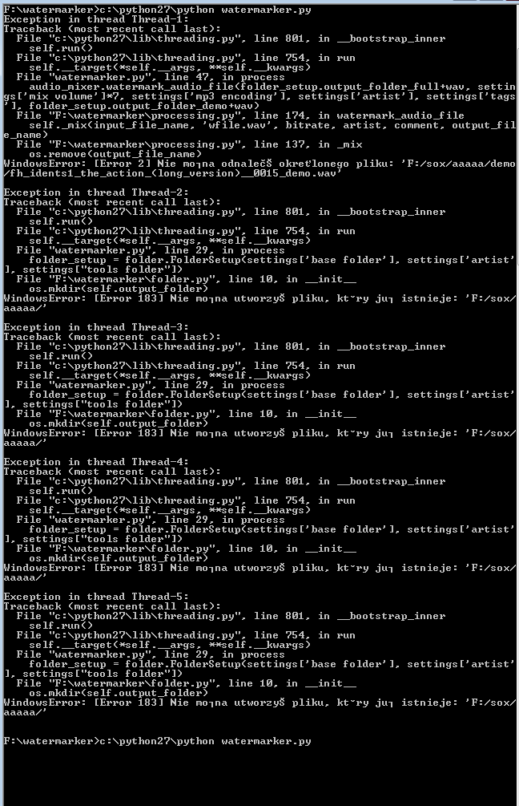
U[7/27/2016 2:06:30 PM] Ryan Venter: Thank you for sending a long report about the points. This way I can go through everything systematically and do what needs to be done. Ok just regarding most of the point above the reason they are not working is the program runs in sequence and if one step doesn’t work it will stop. In the attached document there was one picture of the command line output. I am sorry to ask you but can you please translate the following for me -> Nie morna odnalecs okretlonego pliku: xxxxxx
[7/27/2016 2:07:11 PM] Ryan Venter: and also -> Nie morna utworzyS pliku, kt-ry jur istnieje: XXXX
[7/27/2016 3:24:32 PM] Wojciech Panufnik: Hi Ryan, thank you for your reply. Here is the translation:
Nie morna odnalecs okretlonego pliku: xxxxxx
Unable to find a specified file: xxxxx
and also -> Nie morna utworzyS pliku, kt-ry jur istnieje: XXXX
Unable to open the file, which already exists: xxxx
Everything that you noted in point 3 was due to a cascading effect, due to the error messages that you seen on the command prompt. I have added extra code to make sure the program ignores existing folder creation (which should stop the error messages). This will in turn allow the rest of the code to run smoothly. If the problem persists then please send me a copy of the files you are using as input, and the exact steps you are taking so that I can find out what is going on here. I think is should be fixed by now.
4. What is mp3 lame algorithm used: stereo, join stereo, or?
I have not specified any stereo setting. According to the lame documentation, if nothing is specified then the program uses the same stereo/mono setting of the highest of the two input files.
5. In the directory FULL, FLAC, MP3 there are files with "_demo" suffix. "_demo" suffix had to be added only to files which are in DEMO folder!
What I have done so far is add the bit_depth_suffix_string | timing_suffix_string | demo_suffix_string | prefix_string | suffix_string to all the files in mp3, flac, full and demo (basically before processing was done). Should all these only be done to the demo folder, or should the following bit_depth_suffix_string | timing_suffix_string | prefix_string | suffix_string be done to all and then only demo_suffix_string be put into demo with the others?
So just to clarify, should the naming stuff be done only to the demo folder or all? Or should it all be done to all except for demo (which should only be in demo folder?)
6. MP3 folder contains mp3 files which has no tags, they should contain id tags!
mp3 folder now also contains the same tags as the demo folder mp3 files
7. FULL folder should contains .wav file but they also shoould
8. No preview function at all ???
The program is taking an entire list of audio files and needs to process them. What do you suggest with a preview function? How would you like it to be implemented? Can we leave this for the next milestone as it was not in the original specs?
9. NO _HD24 suffix for files which orginal .wav files had bit depth bigger than 16 bit
Fixed
10. NO convert to 8, 16, 24 bits function
I went though the specs, I am not clear where in the process you want this to be done. Should the original files be converted and then saved in the [full] folder OR should the filer in the [demo] folder be converted to 8/16/24 bit?
11. Regarding the specification, How do I configure:
- w-file time offset
This is another feature and I will do it for you but lets 1st make sure everything else ifs working 100%
- delete “org (dir)” (on/off) after processing
This feature is already implemented, just unclick the org folder clickbox. If not selected the org folder will be deleted after the processing is done.
12. According the specification there is no ftp upload of entire directory processed (i.e. “wojciech panufnik”) conatining four subdirectories (full, mp3, flac, demo) of particulair composer to the defined directory on ftp.
Can you please explain what you mean. What needs to be done?
13. There should be some kind of protection (code?) to use this tool (configurable).
What is protection code? And what do you mean with configurable? Sorry, you have to be specific because as we have discovered before, there is a large amount of possible interpretations and I just want to be clear?
14. How can I change configuration of mixing table? Can it be in a separate txt file which I can swap in case of using a different needs (a different mixing profile)? I will be using watermarker also to watermark very very short files (like sound effects) I am sure I need a different mixing table for that or at least configurable w-file delay/offset which I described in the specifications.
Same as point 11 above, this is another feature and I will do it for you but lets 1st make sure everything else ifs working 100%

Change regarding folder setup
I realized that you may want to process files for the same artist (but different audio files) at different times, and not just one time. Currently, because you have requested for the original folder to be copied, it would not be possible to reuse the same output folder because the org folder will then contain both copies of different processing sessions. Also there may be files with the same name (may be the same file or may even be a different file) which will be overwritten and maybe you don’t want an original file with the same filename as a new file to be overwritten.
To alleviate this, I have added an output folder on the GUI. So for each processing pass you will need to specify where the files need to be output. Then if you want to merge these then you can simply use windows to move the second session files to the 1st session and then select which files you wish to keep, copy, replace, etc.
The specified folder must not exist on hdd, if it does then the GUI will notify you to use another folder. This way it is guaranteed that only the files in the new encoding session will be encoded and that no ‘older’ files be overwritten, and also that older files will not be recoded again with new encoding settings.
The artist field will be kept as this field is used for the artist tag feature.

Original specification
I need Windows tool which will be batch processing audio files. It does conversion, renaming, sound processing and most of all - mixing up two audio files into one in batch process. Possibly doing a few different things like uploading/downloading files from/to server.

The variety of input audio files (let's call them i-files) will be mixed in a batch process with one audio file (let's call it w-file) which will be chosen/selected before starting the process. The aim of this process is to have one output audio file created out of every pair of I-file and W-file.

The entire software should use SoX (http://sox.sourceforge.net/) as the main script doing the job. The final product should be available as GUI version as well as script version (to be able in the future to run it on remote server).

Brief description of the process:

1. Selecting directorz of input .wav files or .zip (I-files)

a. unzip files if needed
b. renaming files using a few rules (to be provided)
c. option to convert files to 8, 16 or 24 bit format
d. audio normalizing files

2. Mixing

a. mixing every i-file with selected w-file
b. if w-file is shorter than loop w-file n times. Cut tail of w-file as the w-file can not be heard, remaining out of shorter i-file.
c. the most important feature: check volume and dynamics of i-file and set the w-file volume to the desired level. I.e. If I-file has silent intro, or some silet parts, the program have to change volume of w-file for this area before mixing it in. If i-file has some dynamic parts, which are very loud the program should have to rise volume of w-file . The mixing process have to be done dynamically thus in the output file you can hear w-file mixed which is not too loud and not too silent for entire audio file. As it's not possible to have one average setting, the volume of the w-file in the mix have to be controlled during the mix taking into consideration what is current dynamics of i-file.

3. Output files, in the directory output (configurable name for each output)

a. directory "full" with original wav files after renaming (1b)
b. directory "flac" with original wav files converted to .flac format
c. directory "demo" consisting combined files. Those files have the same name as "full" files with added suffix "_MMSS" (minutes and seconds, the timing of audio file) + "_demo".
d. directory "mp3" full files converted to mp3 format (with configurable bitrate)

Main configuration

name of directories, all mp3 id tags, all wav id tags, option to convert to/from 8/16/24 bit,
ftp upload, bitrate, volume mixing offset, source directory (also possibly of directory on server), destination directory, upload to ftp, the directory of w-file(s), selecting different w-files, delay (added silence before mixing-in w-file), additional optional prefix, suffix for all files.

Legal requirements

All copyrights have to be transferred to me after job is complete. The source code is a must.
There is a possibility of developing this tool in future so it have to be contain readable code with all sources. Compiled format with GUI to run under Windows. Script format to run it from server.

Final notes.
Detailed description may feature some additional things or configurations. The core feature of this tool is to mix two files and make it possible to differ the volume of w-file according to a current volume of i-file. It its the most important feature. W-file is 15 seconds audio file consist of some spoken words.

Final words
From my computer it all works fine, according to the points above.

Point 5
Please just clarify, it will take me 5 minutes to make necessary changes.

Point 10
Please just clarify. I have already implemented the GUI code and I just need to know when to do the processing pre- or post renaming and where to put the files.

Point 11, 14
Once we know everthing else is working I will move the wfile mixing table code into the settings file, so that you can edit everything in the same file, and make different versions and load them as you see fit.

